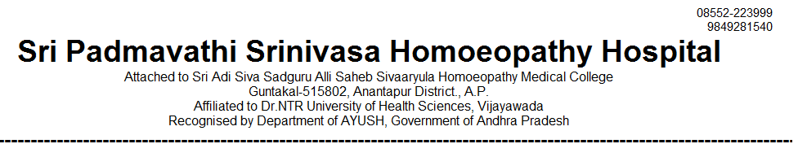
OUT PATIENT STATEMENT FOR THE YEAR JAN-2024 TO DEC - 2024

SNO | MONTH | GENERAL MEDICINE | GYNAECOLOGY /OBSTERICIAN | PAEDIATRICS | SURGERY | TOTAL
1 | 2024 - JAN | 3227 | 1549 | 996 | 598 | 6370
2 | 2024 - FEB | 3171 | 1520 | 1003 | 568 | 6262
3 | 2024 – MAR | 3215 | 1571 | 992 | 589 | 6367
4 | 2024 – APR | 3086 | 1544 | 1049 | 589 | 6268
5 | 2024 – MAY | 3215 | 1630 | 1293 | 627 | 6765
6 | 2024 – JUN | 2951 | 1535 | 1243 | 440 | 6169
7 | 2024 – JUL | 3050 | 1583 | 1307 | 624 | 6564
8 | 2024 – AUG | 3231 | 1690 | 1233 | 642 | 6796
9 | 2024 – SEP | 3165 | 1600 | 1217 | 675 | 6657
10 | 2024 - OCT | 3823 | 1916 | 1416 | 773 | 7928
11 | 2024 - NOV | 3621 | 1863 | 1387 | 760 | 7631
12 | 2024 - DEC | 3793 | 1912 | 1299 | 732 | 7736
 | TOTAL | 39548 | 19913 | 14435 | 7617 | 81513


